Backend Setup

Contents

IDE: 3

Python: 3

Django: 3

Clone the Git Project: 4

Open the project folder in VS Code: 4

Run the project: 4

# IDE:

Install VS Code from the link below:

<https://code.visualstudio.com/docs/?dv=win64user>

# Python:

* Download and install the latest version of Python from the below link:

<https://www.python.org/downloads/>

* Set python in Environment Variables Path of your system.

# Django:

Open command prompt and use the below command to install Django:

>> **python3 -m pip install Django**

To verify if Django is correctly installed, use the below command:

>> **django-admin**

You should see a message as in the below screenshot:

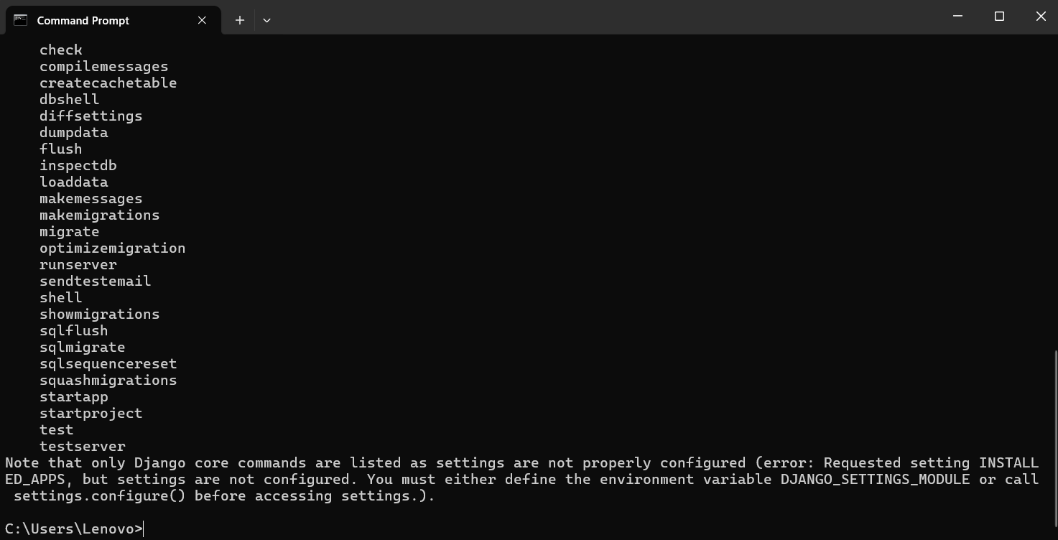

# Clone the Git Project:

Clone the below github repository into your local machine:

# Open the project folder in VS Code:

* Open VS Code
* Click on File -> Open Folder
* Browse to the Cloned folder and click Open.

# Run the project:

To start the project, run the below command on terminal:

>>**python manage.py startapp <appName>**